**Installtion of BW and TEA.**

**TIBCO BW6.3.1 installtion:-**

**Step:-1 Run following command and follow the steps as per the screen shot.**

[tibcouser1@tibcodev11 BW]$ ./TIBCOUniversalInstaller-lnx-x86-64.bin

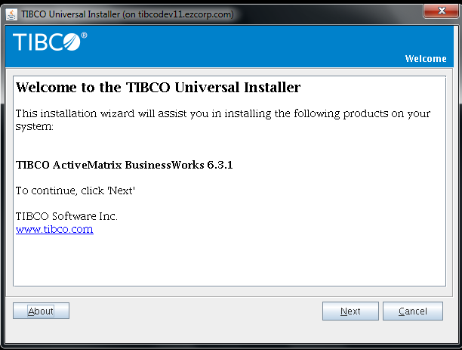

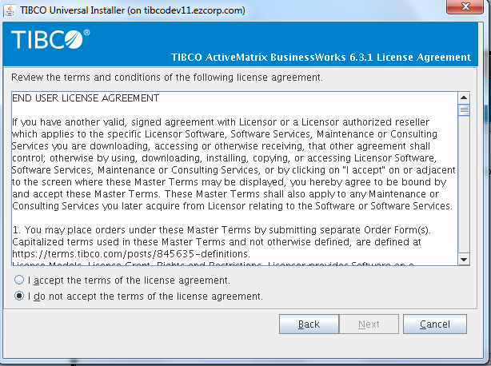

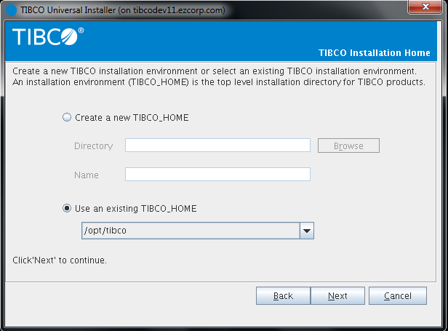

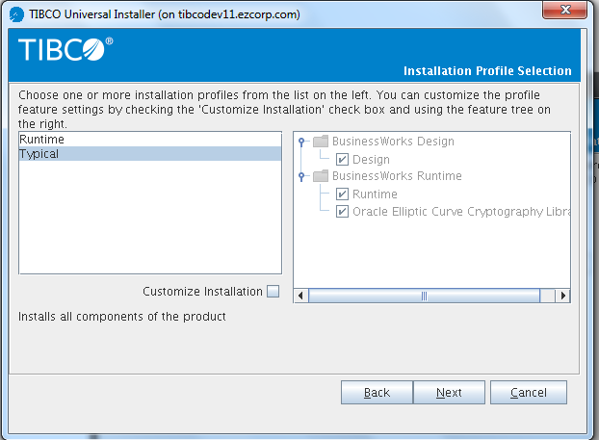

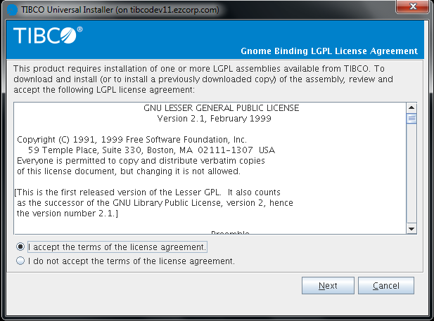

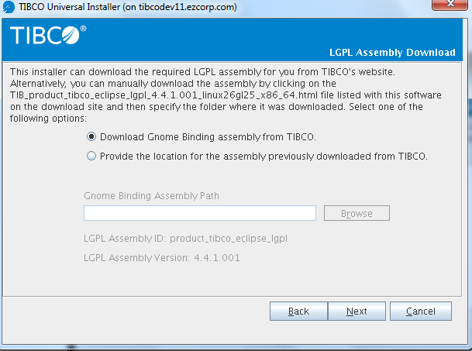

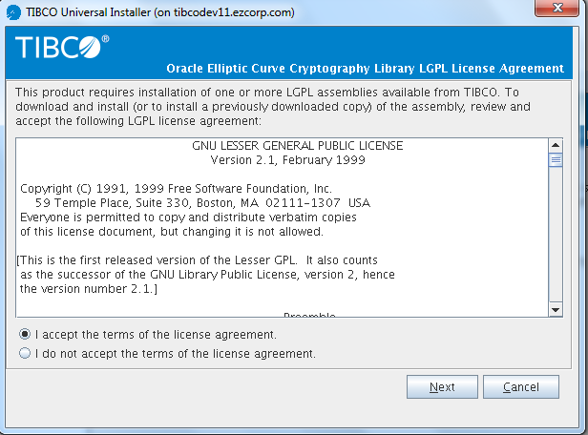

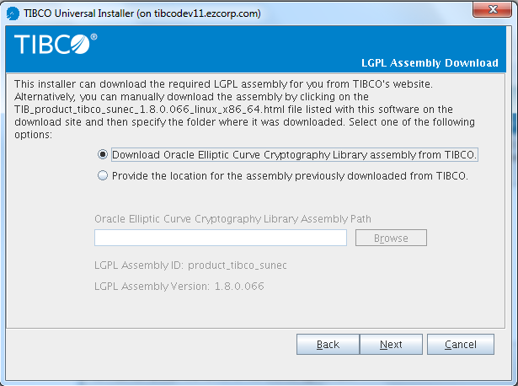

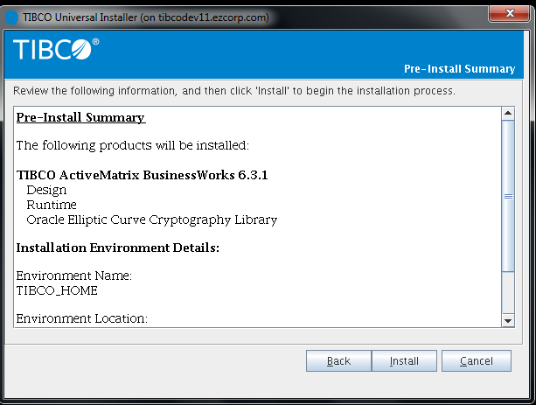

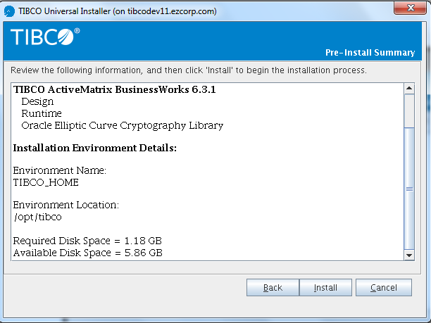

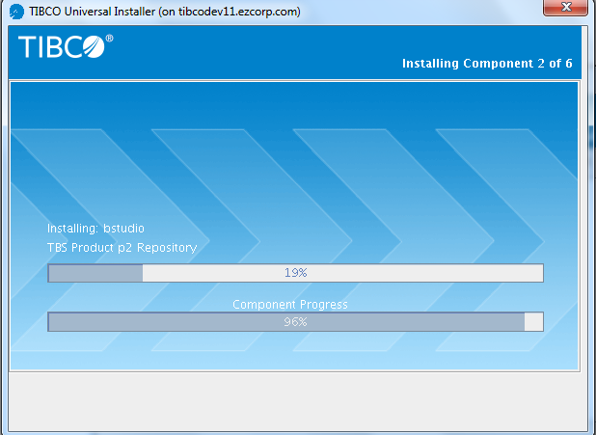

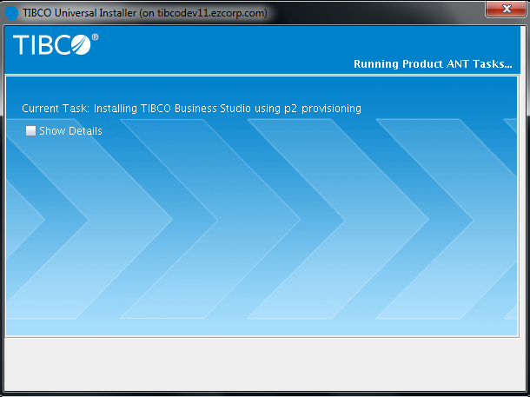

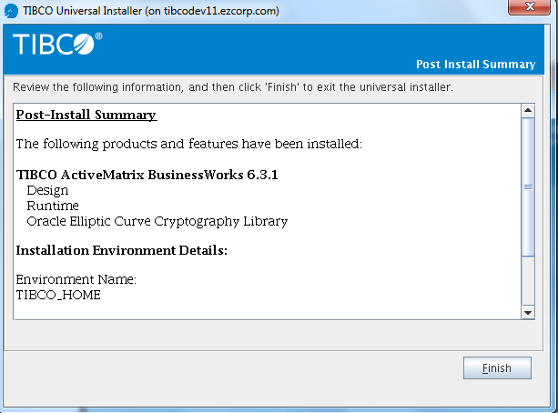

Installation of BW6.3.1 is completed.

**Installation of TEA:-**

[tibcouser1@tibcodev11 TEA]$ ./TIBCOUniversalInstaller-lnx-x86-64.bin

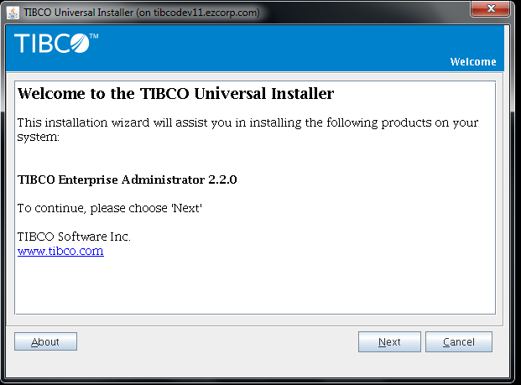

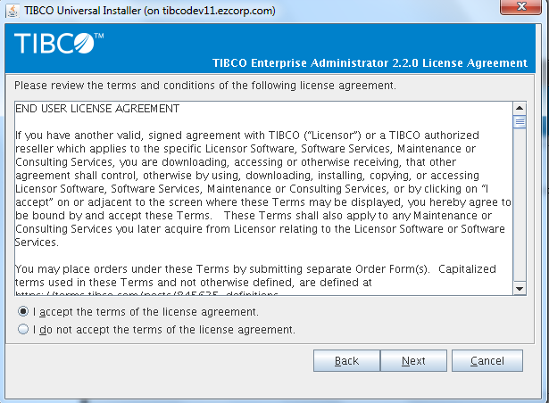

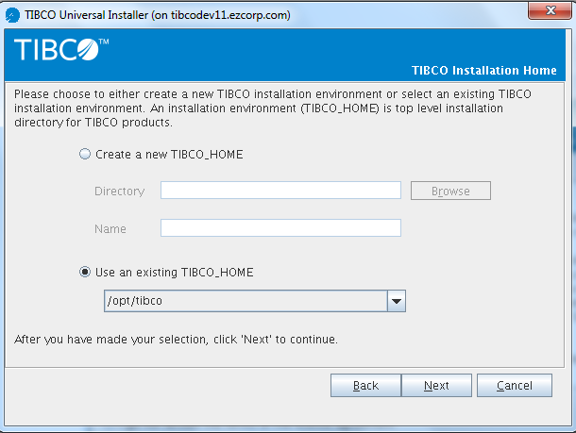

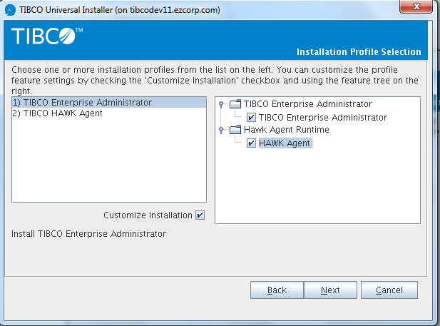

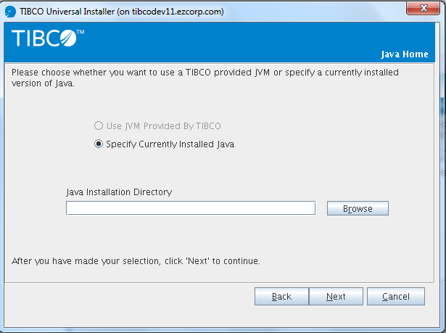

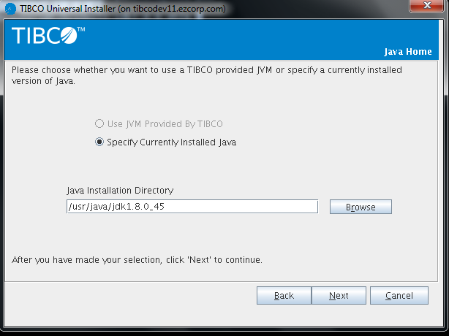

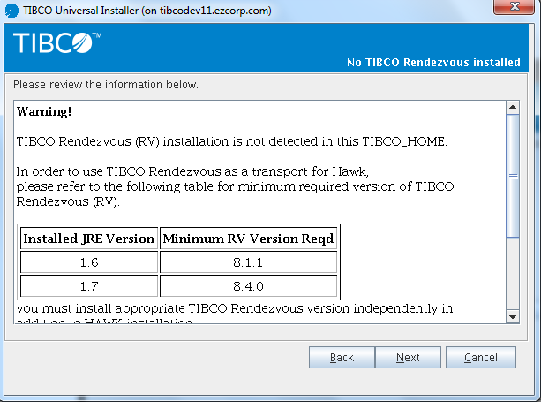

Warning! TIBCO Rendezvous (RV) installation is not detected in this TIBCO_HOME. In order to use TIBCO Rendezvous as a transport for Hawk, please refer to the following table for minimum required version of TIBCO Rendezvous (RV).

Installed JRE Version

Minimum RV Version Reqd

1.6

8.1.1

1.7

8.4.0

you must install appropriate TIBCO Rendezvous version independently in addition to HAWK installation. If you install TIBCO Rendezvous after TIBCO Hawk installation, please make sure to set RV_HOME pointing to the Rendezvous installation home directory in the Hawk TRA files. Alternatively, if you would prefer to use TIBCO DataGrid - available out-of-the-box - as the default mode of transport, please modify HAWK configuration files before working with any of HAWK components.

Warning! TIBCO Enterprise Message Service (EMS) installation is not detected in this TIBCO_HOME. In order to use TIBCO EMS as a transport for Hawk, please refer to the following table for minimum required version of TIBCO EMS.

Installed JRE Version

Minimum EMS Version Reqd

1.6

6.0.0

1.7

6.3.0

you must install appropriate TIBCO EMS version independently in addition to HAWK installation. If you install TIBCO EMS after TIBCO Hawk installation, please make sure to set EMS_HOME pointing to the EMS installation home directory in the Hawk TRA files.

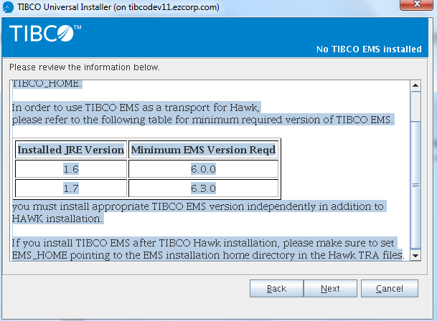

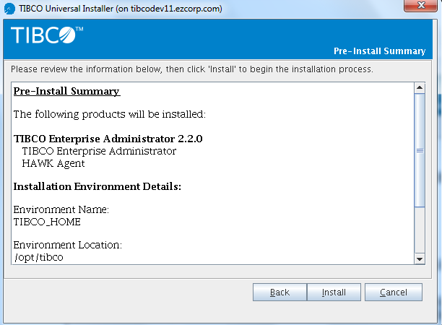

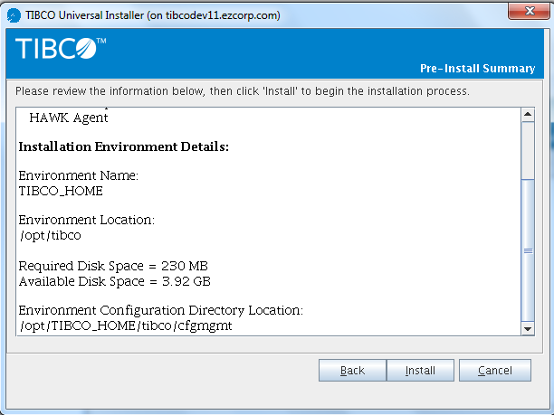

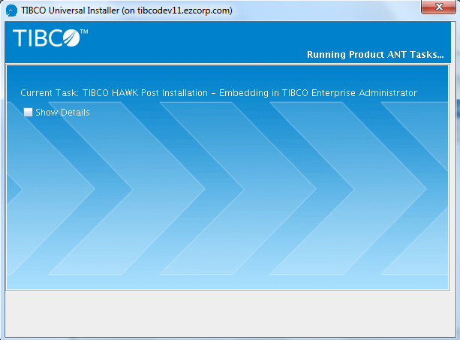

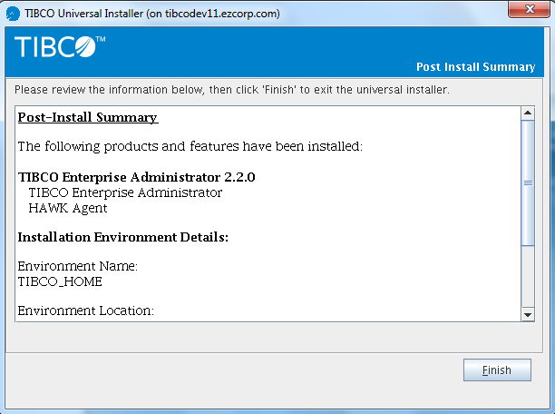

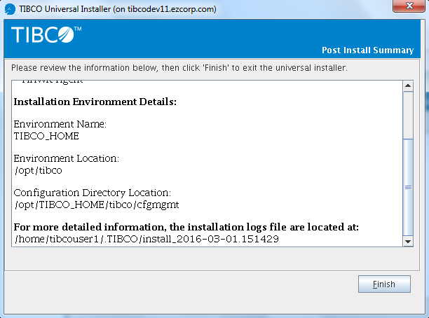

Post-Install Summary

The following products and features have been installed: TIBCO Enterprise Administrator 2.2.0    TIBCO Enterprise Administrator    HAWK Agent

Installation Environment Details:

Environment Name: TIBCO_HOME

Environment Location: /opt/tibco

Configuration Directory Location: /opt/TIBCO_HOME/tibco/cfgmgmt

For more detailed information, the installation logs file are located at: /home/tibcouser1/.TIBCO/install_2016-03-01.151429

**To Install HF for TEA:-**

[tibcouser1@tibcodev11 HF]$ ./TIBCOUniversalInstaller-lnx-x86-64.bin

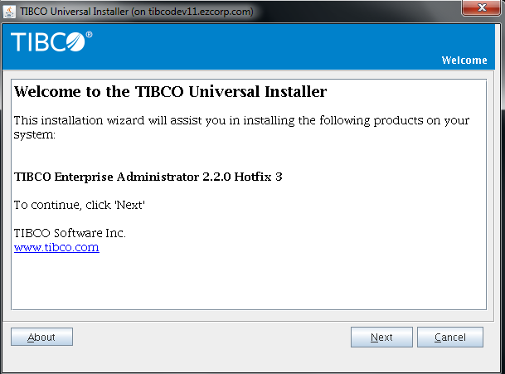

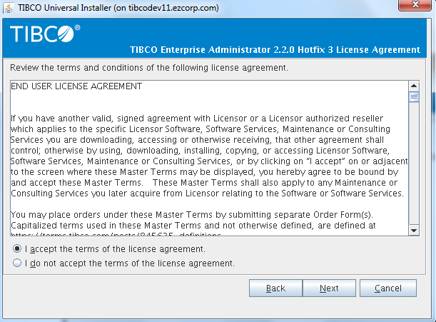

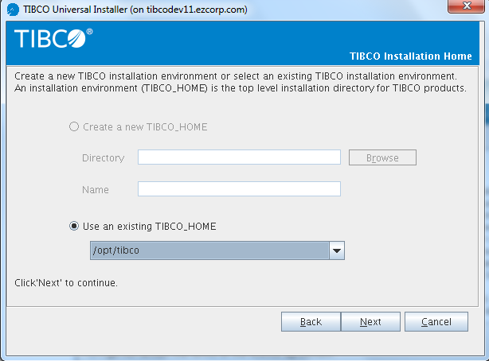

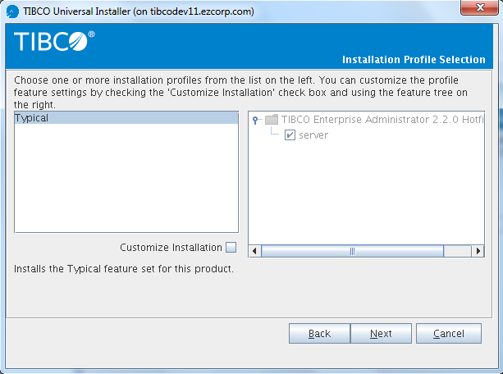

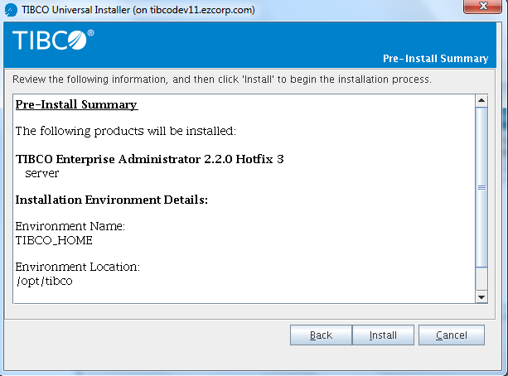

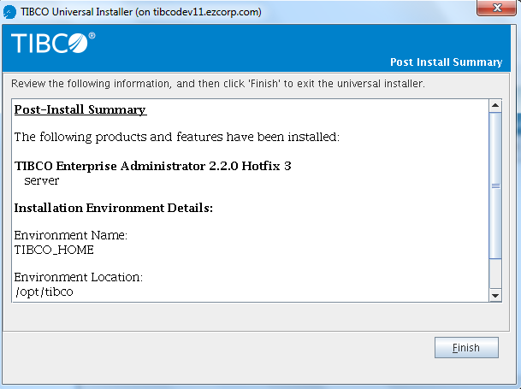

**Configuration of BW6 with DB and EMS:**

Step:-1 Update following properties in bwagent.ini file at TIBCO_BWHOME/config

**bwagent properties for Multi-Agent, Multi-Machine Environments:**

* bw.agent.technology.type

[Set to either: ActiveSpaces DBEMS]

* bw.agent.network.name [The name of the network. Must be the same for all the bwagents in the network.]
* bw.agent.memberName :-

The name of the bwagent. Must be unique within the network

Step 2:-

Configuration in bwagent_db.json file for server where tea is installed.

bwagentnetworkname: BW6Network,

membername: "tibcodev11.ezcorp.com",

db: true,

dbtype: sqlserver,

dbdriver: "com.microsoft.sqlserver.jdbc.SQLServerDriver",

dbconnectionurl: "jdbc:sqlserver://EZQADB3.ezcorp.com:62821;databaseName=bwadmindb",

dbuser: bwuser,

dbpassword: bwuser,

emsserverurl: "tcp://tibcodev11.ezcorp.com:7222",

emsusername: admin,

emsuserpassword: "",

Configuration in bwagent_db.json file for server where only bw is installed.

bwagentnetworkname: BW6Network,

membername: "tibcodev12.ezcorp.com",

db: true,

dbtype: sqlserver,

dbdriver: "com.microsoft.sqlserver.jdbc.SQLServerDriver",

dbconnectionurl: "jdbc:sqlserver://EZQADB3.ezcorp.com:62821;databaseName=bwadmindb",

dbuser: bwuser,

dbpassword: bwuser,

emsserverurl: "tcp://tibcodev11.ezcorp.com:7222",

emsusername: admin,

emsuserpassword: "",

teaserverurl: "http://tibcodev11.ezcorp.com:8777/tea",

governanceenabled: "false",

governancejmsserverurl: "tcp://tibcodev11.ezcorp.com:7222",

governancejmsusername: admin,

governancejmsuserpassword: "",

Step 3:-

* Run the bwadmin config command with the -cf option to create an .ini file in the correct location. BW_HOME\bin>

./bwadmin config -cf ../config/bwagent_db.json agent

* Start the tea. /opt/tibco/tea/2.2/bin command ./tea
* Start the bwagents. /opt/tibco/bw/6.3/bin ./bwagent

Once above steps are done perform following things:-

**Setting up mode:-**

[tibcouser1@tibcodev13 bin]$ ./bwadmin mode enterprise

TIBCO ActiveMatrix BusinessWorks version 6.3.1, build V12, 2016-01-27

Admin mode set to enterprise

[tibcouser1@tibcodev13 bin]$

**Registration of BW agent:-**

[tibcouser1@tibcodev13 bin]$ ./bwadmin registerteaagent http://tibcodev13.ezcorp.com:8777/tea/

TIBCO ActiveMatrix BusinessWorks version 6.3.1, build V12, 2016-01-27

Connecting to the BW Agent using

TIBCO ActiveSpaces (Java). Enterprise Edition. Version 2.1.4.022

[tibcouser1@tibcodev13 bin]$ ./bwadmin registerteaagent http://tibcodev13.ezcorp.com:8777/tea/

TIBCO ActiveMatrix BusinessWorks version 6.3.1, build V12, 2016-01-27

Connecting to the BW Agent using

TIBCO ActiveSpaces (Java). Enterprise Edition. Version 2.1.4.022

Connected to BW Agent

TIBCO-BW-ADMIN-CLI-300010: Registered TEA Agent [tibcodev13.ezcorp.com] with TEA Server.

**Create Domain:-**

[tibcouser1@tibcodev13 bin]$ ./bwadmin create domain EZ-CS-DEV1

TIBCO ActiveMatrix BusinessWorks version 6.3.1, build V12, 2016-01-27

Connecting to the BW Agent using

TIBCO ActiveSpaces (Java). Enterprise Edition. Version 2.1.4.022

Connected to BW Agent

TIBCO-BW-ADMIN-CLI-300100: Domain [EZ-CS-DEV1] created.

**Show Domain:-**

[tibcouser1@tibcodev13 bin]$ ./bwadmin show domain

TIBCO ActiveMatrix BusinessWorks version 6.3.1, build V12, 2016-01-27

Connecting to the BW Agent using

TIBCO ActiveSpaces (Java). Enterprise Edition. Version 2.1.4.022

Connected to BW Agent

Domains:

EZ-CS-DEV1

**Create Appsapce:-**

[tibcouser1@tibcodev13 bin]$ ./bwadmin create -d EZ-CS-DEV1 appspace EZ-DEV-Appspace1

TIBCO ActiveMatrix BusinessWorks version 6.3.1, build V12, 2016-01-27

Connecting to the BW Agent using

TIBCO ActiveSpaces (Java). Enterprise Edition. Version 2.1.4.022

Connected to BW Agent

TIBCO-BW-ADMIN-CLI-300200: AppSpace [EZ-DEV-Appspace1] in Domain [EZ-CS-DEV1] created.

[tibcouser1@tibcodev13 bin]$

**Create APPNode:-**

[tibcouser1@tibcodev13 bin]$ ./bwadmin create -domain EZ-CS-DEV1 -appspace EZ-DEV-Appspace1 -httpPort 8060 appnode EZ-DEV-APPNODE1

TIBCO ActiveMatrix BusinessWorks version 6.3.1, build V12, 2016-01-27

Connecting to the BW Agent using

TIBCO ActiveSpaces (Java). Enterprise Edition. Version 2.1.4.022

Connected to BW Agent

TIBCO-BW-ADMIN-CLI-300300: AppNode [EZ-DEV-APPNODE1] in AppSpace [EZ-DEV-Appspace1], Domain [EZ-CS-DEV1] created.

**Upload EAR:-**

[tibcouser1@tibcodev13 bin]$ ./bwadmin upload -domain EZ-CS-DEV1 /opt/soft/tibco.bw.sample.binding.rest.Basic.application_1.0.0.ear

TIBCO ActiveMatrix BusinessWorks version 6.3.1, build V12, 2016-01-27

Connecting to the BW Agent using

TIBCO ActiveSpaces (Java). Enterprise Edition. Version 2.1.4.022

Connected to BW Agent

TIBCO-BW-ADMIN-CLI-300410: Uploaded archive [/opt/soft/tibco.bw.sample.binding.rest.Basic.application_1.0.0.ear].

**Show Archives:**

[tibcouser1@tibcodev13 bin]$ ./bwadmin show -domain EZ-CS-DEV1 archives

TIBCO ActiveMatrix BusinessWorks version 6.3.1, build V12, 2016-01-27

Connecting to the BW Agent using

TIBCO ActiveSpaces (Java). Enterprise Edition. Version 2.1.4.022

Connected to BW Agent

**Name**  **Path**  **Version**  **Domain**  **AppName**  **Uploaded Time**  **Uploaded By**  **Size(Kb)**

tibco.bw.sample.binding.rest.Basic.application_1.0.0.ear 1.0.0.20160226115356 EZ-CS-DEV1 tibco.bw.sample.binding.rest.Basic.application 2016/02/26 12:01:54 admin 37

**Start AppSpace:-**

[tibcouser1@tibcodev13 bin]$ ./bwadmin start -domain EZ-CS-DEV1 appspace EZ-DEV-Appspace1

TIBCO ActiveMatrix BusinessWorks version 6.3.1, build V12, 2016-01-27

Connecting to the BW Agent using

TIBCO ActiveSpaces (Java). Enterprise Edition. Version 2.1.4.022

Connected to BW Agent

TIBCO-BW-ADMIN-CLI-300203: AppSpace [EZ-DEV-Appspace1] in Domain [EZ-CS-DEV1] started.

**Deploy application:-**

[tibcouser1@tibcodev13 bin]$ ./bwadmin deploy -domain EZ-CS-DEV1 -appspace EZ-DEV-Appspace1 tibco.bw.sample.binding.rest.Basic.application_1.0.0.ear

TIBCO ActiveMatrix BusinessWorks version 6.3.1, build V12, 2016-01-27

Connecting to the BW Agent using

TIBCO ActiveSpaces (Java). Enterprise Edition. Version 2.1.4.022

Connected to BW Agent

TIBCO-BW-ADMIN-CLI-300403: Deployed application [tibco.bw.sample.binding.rest.Basic.application:1.0].

**Show Deployed Application:-**

[tibcouser1@tibcodev13 bin]$ ./bwadmin show -domain EZ-CS-DEV1 application

TIBCO ActiveMatrix BusinessWorks version 6.3.1, build V12, 2016-01-27

Connecting to the BW Agent using

TIBCO ActiveSpaces (Java). Enterprise Edition. Version 2.1.4.022

Connected to BW Agent

**Domain:** EZ-CS-DEV1

**Name Version AppSpace Profile Status Deployment Status (Running/Total)**

tibco.bw.sample.binding.rest.Basic.application 1.0 EZ-DEV-Appspace1 WindowsProfile.substvar Stopped Deployed (0/1)

**Starting Application:-**

[tibcouser1@tibcodev13 bin]$ ./bwadmin start -domain EZ-CS-DEV1 -appspace EZ-DEV-Appspace1

TIBCO ActiveMatrix BusinessWorks version 6.3.1, build V12, 2016-01-27

Connecting to the BW Agent using

TIBCO ActiveSpaces (Java). Enterprise Edition. Version 2.1.4.022

Connected to BW Agent

TIBCO-BW-ADMIN-CLI-300203: AppSpace [EZ-DEV-Appspace1] in Domain [EZ-CS-DEV1] started.

**Commands for QA env only for help.**

[tibcouser1@tibcodev11 bin]$ ./bwadmin registerteaagent http://tibcodev11.ezcorp.com:8777/tea/

TIBCO ActiveMatrix BusinessWorks version 6.3.1, build V12, 2016-01-27

Connecting to the BW Agent using

TIBCO ActiveSpaces (Java). Enterprise Edition. Version 2.1.4.022

Connected to BW Agent

TIBCO-BW-ADMIN-CLI-300010: Registered TEA Agent [tibcodev11.ezcorp.com] with TEA Server.

[tibcouser1@tibcodev11 bin]$ ./bwadmin create domain EZ-CS-QA1

TIBCO ActiveMatrix BusinessWorks version 6.3.1, build V12, 2016-01-27

Connecting to the BW Agent using

TIBCO ActiveSpaces (Java). Enterprise Edition. Version 2.1.4.022

Connected to BW Agent

TIBCO-BW-ADMIN-CLI-300100: Domain [EZ-CS-QA1] created.

[tibcouser1@tibcodev11 bin]$ ./bwadmin show domain

TIBCO ActiveMatrix BusinessWorks version 6.3.1, build V12, 2016-01-27

Connecting to the BW Agent using

TIBCO ActiveSpaces (Java). Enterprise Edition. Version 2.1.4.022

Connected to BW Agent

Domains:

EZ-CS-QA1

[tibcouser1@tibcodev11 bin]$

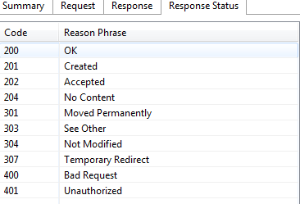

[tibcouser1@tibcodev11 bin]$ ./bwadmin mode enterprise

TIBCO ActiveMatrix BusinessWorks version 6.3.1, build V12, 2016-01-27

Admin mode set to enterprise

[tibcouser1@tibcodev11 bin]$ ./bwadmin registerteaagent http://tibcodev11.ezcorp.com:8777/tea/

TIBCO ActiveMatrix BusinessWorks version 6.3.1, build V12, 2016-01-27

Connecting to the BW Agent using

TIBCO ActiveSpaces (Java). Enterprise Edition. Version 2.1.4.022

Connected to BW Agent

TIBCO-BW-ADMIN-CLI-300010: Registered TEA Agent [tibcodev11.ezcorp.com] with TEA Server.

[tibcouser1@tibcodev11 bin]$ ./bwadmin create domain EZ-CS-QA1

TIBCO ActiveMatrix BusinessWorks version 6.3.1, build V12, 2016-01-27

Connecting to the BW Agent using

TIBCO ActiveSpaces (Java). Enterprise Edition. Version 2.1.4.022

Connected to BW Agent

TIBCO-BW-ADMIN-CLI-300100: Domain [EZ-CS-QA1] created.

[tibcouser1@tibcodev11 bin]$ ./bwadmin show domain

TIBCO ActiveMatrix BusinessWorks version 6.3.1, build V12, 2016-01-27

Connecting to the BW Agent using

TIBCO ActiveSpaces (Java). Enterprise Edition. Version 2.1.4.022

Connected to BW Agent

Domains:

EZ-CS-QA1

[tibcouser1@tibcodev11 bin]$ ./bwadmin create -d EZ-CS-QA1 appspace EZ-QA1-Appspace1

TIBCO ActiveMatrix BusinessWorks version 6.3.1, build V12, 2016-01-27

Connecting to the BW Agent using

TIBCO ActiveSpaces (Java). Enterprise Edition. Version 2.1.4.022

Connected to BW Agent

TIBCO-BW-ADMIN-CLI-300200: AppSpace [EZ-QA1-Appspace1] in Domain [EZ-CS-QA1] created.

[tibcouser1@tibcodev11 bin]$ ./bwadmin create -domain EZ-CS-QA1 -appspace EZ-QA1-Appspace1 -httpPort 8060 appnode EZ-QA1-APPNODE1

TIBCO ActiveMatrix BusinessWorks version 6.3.1, build V12, 2016-01-27

Connecting to the BW Agent using

TIBCO ActiveSpaces (Java). Enterprise Edition. Version 2.1.4.022

Connected to BW Agent

TIBCO-BW-ADMIN-CLI-300300: AppNode [EZ-QA1-APPNODE1] in AppSpace [EZ-QA1-Appspace1], Domain [EZ-CS-QA1] created.

[tibcouser1@tibcodev11 bin]$ hostname

tibcodev11.ezcorp.com

[tibcouser1@tibcodev11 bin]$ ./bwadmin upload -domain EZ-CS-QA1 /opt/soft/CustomerMDM.application_1.0.0.ear

TIBCO ActiveMatrix BusinessWorks version 6.3.1, build V12, 2016-01-27

Connecting to the BW Agent using

TIBCO ActiveSpaces (Java). Enterprise Edition. Version 2.1.4.022

Connected to BW Agent

TIBCO-BW-ADMIN-CLI-300410: Uploaded archive [/opt/soft/CustomerMDM.application_1.0.0.ear].

[tibcouser1@tibcodev11 bin]$ ./bwadmin start -domain EZ-CS-QA1 appspace EZ-QA1-Appspace1

TIBCO ActiveMatrix BusinessWorks version 6.3.1, build V12, 2016-01-27

Connecting to the BW Agent using

TIBCO ActiveSpaces (Java). Enterprise Edition. Version 2.1.4.022

Connected to BW Agent

TIBCO-BW-ADMIN-CLI-300203: AppSpace [EZ-QA1-Appspace1] in Domain [EZ-CS-QA1] started.

[tibcouser1@tibcodev11 bin]$ ./bwadmin deploy -domain EZ-CS-QA1 -appspace EZ-QA1-Appspace1 CustomerMDM.application_1.0.0.ear

TIBCO ActiveMatrix BusinessWorks version 6.3.1, build V12, 2016-01-27

Connecting to the BW Agent using

TIBCO ActiveSpaces (Java). Enterprise Edition. Version 2.1.4.022

Connected to BW Agent

TIBCO-BW-ADMIN-CLI-300403: Deployed application [CustomerMDM.application:1.0].

[tibcouser1@tibcodev11 bin]$ ./bwadmin start -domain EZ-CS-QA1 -appspace EZ-QA1-Appspace1

TIBCO ActiveMatrix BusinessWorks version 6.3.1, build V12, 2016-01-27

Connecting to the BW Agent using

TIBCO ActiveSpaces (Java). Enterprise Edition. Version 2.1.4.022

Connected to BW Agent

TIBCO-BW-ADMIN-CLI-300203: AppSpace [EZ-QA1-Appspace1] in Domain [EZ-CS-QA1] started.

If you are using multiple machines, follow below steps:

Step-1:-

**Setting up mode:-**

[tibcouser1@tibcodev13 bin]$ ./bwadmin mode enterprise

TIBCO ActiveMatrix BusinessWorks version 6.3.1, build V12, 2016-01-27

Admin mode set to enterprise

[tibcouser1@tibcodev13 bin]$

**Creating domain by command line:-**

[tibcouser1@tibcodev11 bin]$ ./bwadmin create domain EZ-CS-QA2

TIBCO ActiveMatrix BusinessWorks version 6.3.1, build V12, 2016-01-27

TIBCO-BW-ADMIN-CLI-300100: Domain [EZ-CS-QA2] created.

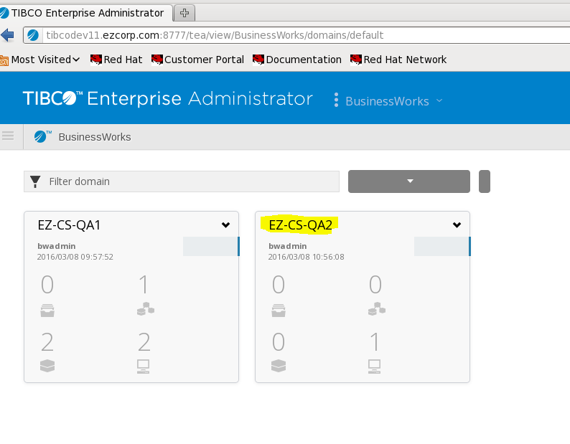

**AppSpace Creation:-**

* Click on domain and select create AppSpace option

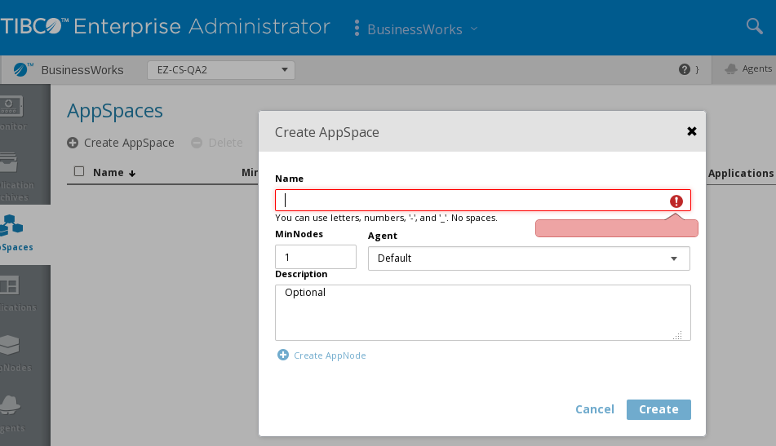

* Fill the Appspace name such as:- EZ-QA1-Appspace2 and keep rest of setting as it is.

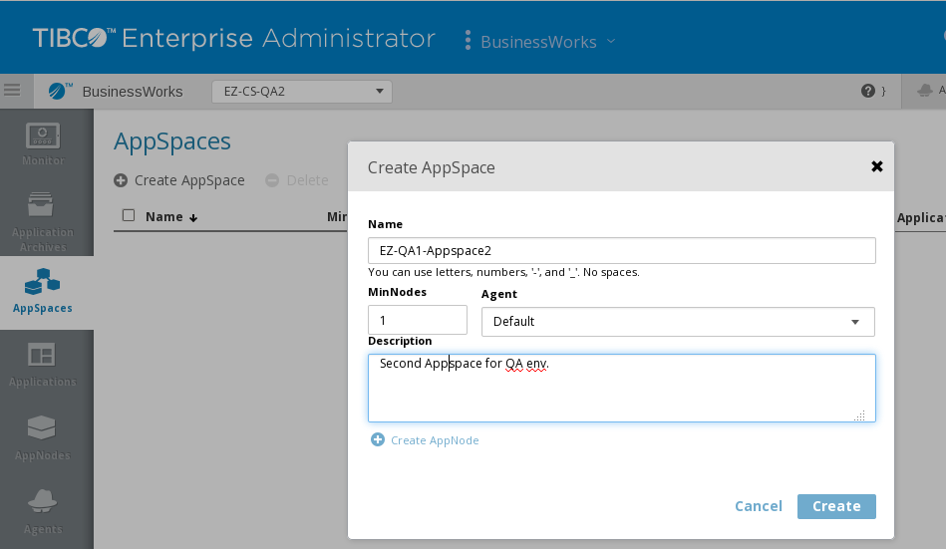

* Click on create.
* Appspace will be created.

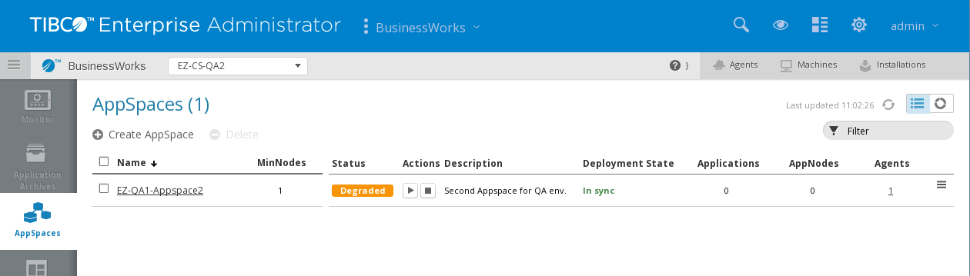

**Create AppNodes:-**

* To create appnodes, click on respective AppSpace and go to AppNode option.

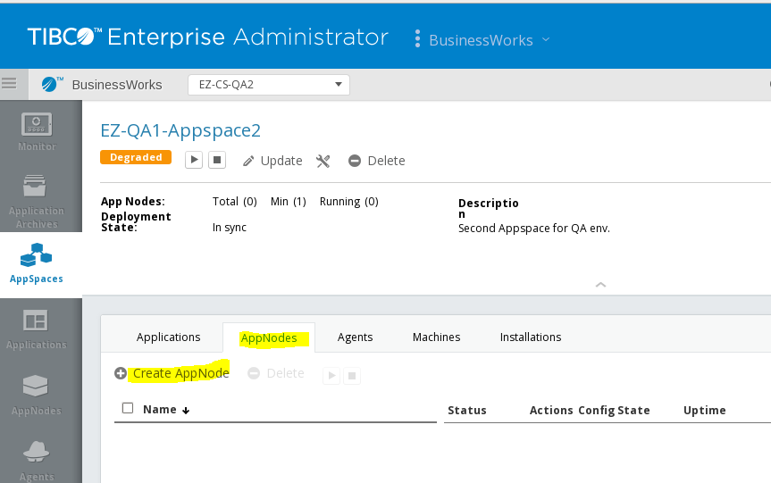

* Select CreateAppNode option.
* Fill required information as below Name and Agent [select required bw agent machine]

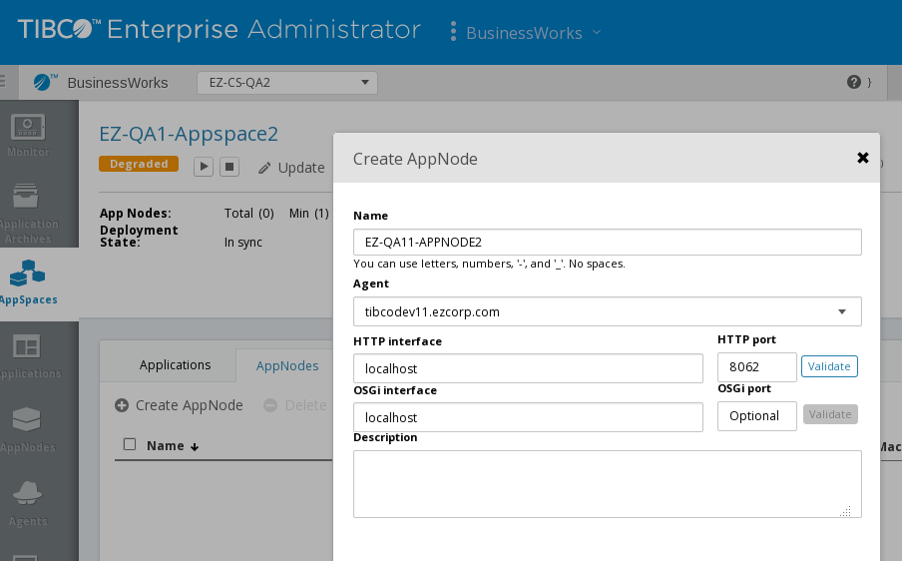

* Click on create.
* Create one more appnode on another bw agent machine.
* Then start the BW APPSpace , nodes will start automatically once appspace is running.
* 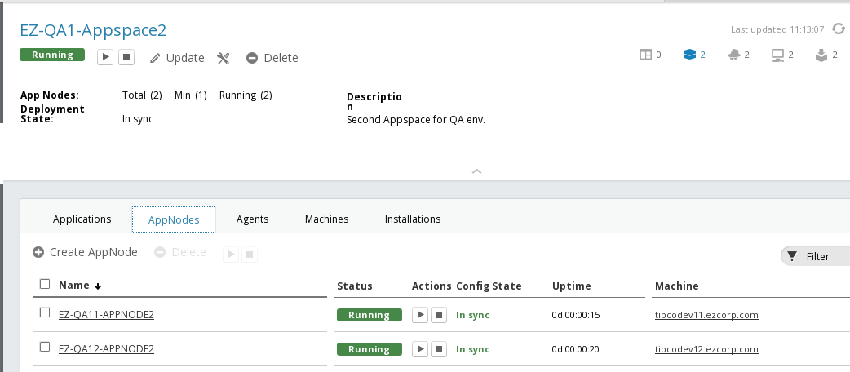
* Deploy the applications.